MEDIA RELEASE

Aurora Expeditions Named World’s Leading Polar Expedition Operator 2023

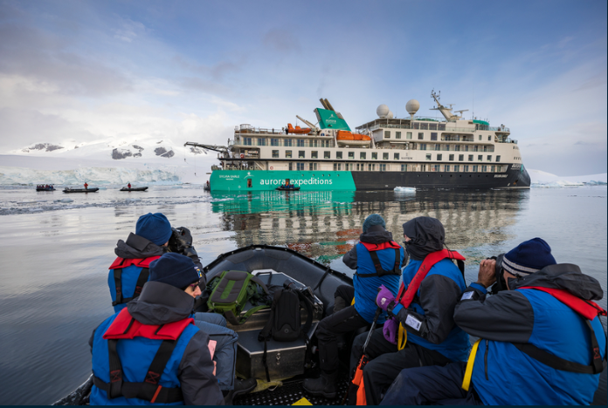

SYDNEY, AUSTRALIA, 4 December 2023 – Aurora Expeditions, the Australian-owned leading expedition travel company, has been named the World's Leading Polar Expedition Operator 2023 for the second consecutive year at the prestigious World Travel Awards, held in Dubai on December 1.

Established 30 years ago, the World Travel Awards are recognised globally as a hallmark of industry excellence, acknowledging, rewarding and celebrating brands, destinations and products across all key sectors of the travel, tourism and hospitality industries.

“It is an incredible honour to receive this award for the second year running,” commented Aurora Expeditions’ Chief Marketing Officer, Hayley Peacock-Gower.

“The polar regions of Antarctica and the Arctic have been our specialty for more than three decades, and it is our commitment to respectful exploration, depth of experience, innovation and passion for immersive, transformative experiences – delivered in a very egalitarian way – that sets us apart in the polar expedition space.

“On our purpose-built small expedition ships, our highly knowledgeable and dedicated Expedition Team takes our passengers to the world’s wildest and most incredible places, as well as some of the most fragile. Our mission is to continue to create unique, life-changing polar expeditions while continuing to advance our sustainability efforts and advocacy for the planet.”

Earlier this month, Aurora Expeditions released its Arctic & Beyond 2025 season, featuring a comprehensive array of departures to the unique and varied destinations of the region including Greenland – whose east, south, west, and northwest coasts will be explored – Svalbard, Norway, Iceland and Canada’s High Arctic via the famed Northwest Passage.

For more information, visit www.aurora-expeditions.com
-END-
Media Contact
MMGY NJF
aurora@njfpr.com

Notes to Editors
Image credits: Zodiac Cruising in Antarctica, Richard I’Anson

About Aurora Expeditions
Aurora Expeditions is an award-winning, Australian-owned expedition company pioneering experiential travel for over 32 years. A pioneer in Polar Expeditions, Aurora is deeply committed to environmentally respectful travel to preserve the beauty and majesty that mother nature possesses, and we take real actions for the care of the planet.

Founded on the guiding principles of adventure and endless exploration, the small ship experience is intimate and friendly. Aurora Expeditions takes travellers on perspective-altering experiences to some of the planet’s most remote and incredible places.

Aurora’s two purpose-built ships, Greg Mortimer and our brand-new small expedition ship Sylvia Earle are designed for global discovery.

