

MEDIA RELEASE

Aurora Expeditions Strengthens North American Presence Following Antarctic Season
US bookings rise 37% year over year
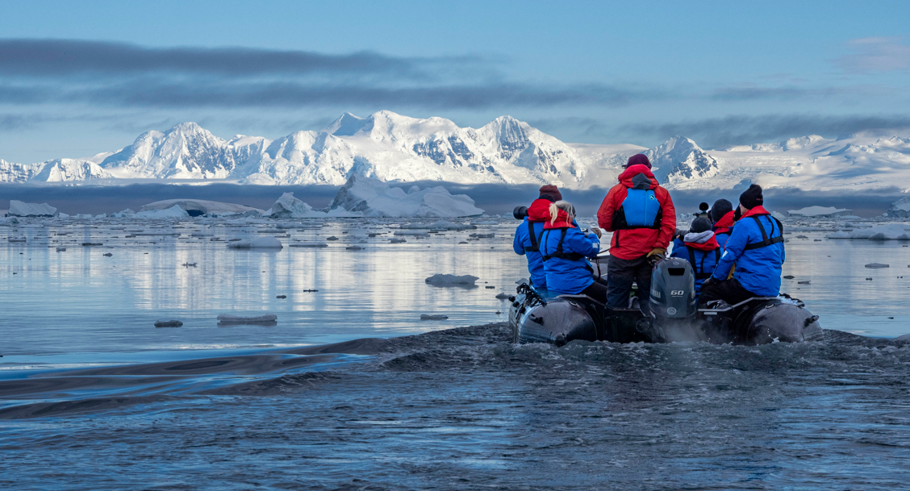

New York, NY — June X, 2026 — Aurora Expeditions has recorded strong growth from the North American market for its 2025/26 Antarctic season, with US bookings increasing by 37% year over year. By comparison, the broader North American Antarctic market grew by 11.5% over the same period, according to IAATO, the International Association of Antarctica Tour Operators, 2025-25 Visitation Report*.

The result reflects the growing importance of North America to Aurora’s global business, with travelers from the region accounting for one in three Aurora expeditioners last season.

Aurora Expeditions’ Head of Global Sales, David Tanguay, said the performance was a positive indication of the company’s continued investment in North America, as well as the strength of its trade partnerships across the region.

“North America continues to be an important market for Aurora Expeditions, and we are grateful for the ongoing support of our valued trade partners,” Tanguay said.

“This growth is encouraging and reflects the increasing interest we are seeing from travelers seeking small-ship, expert-led expeditions to Antarctica. More than ever, travelers are looking for meaningful experiences, more time off ship and a deeper connection to the places they visit — and that has always been central to Aurora’s approach.”

The North American performance comes as Aurora Expeditions delivered its largest Antarctic season to date, operating 30 voyages and facilitating an estimated 819 landings.

Aurora’s expedition model is built around small-group exploration, supported by a 1:7 expedition guide-to-guest ratio and one of the most robust activity programs in Antarctica, with expeditioners able to take part in Zodiac cruising, shore landings, kayaking, snorkeling, skiing, camping, photography, diving and more.

“As we continue to grow in North America, our focus remains on supporting our partners with the product knowledge, tools and expertise they need to convert this demand,” Tanguay said.

Aurora Expeditions’ 2026/27 Antarctic voyages are now open for booking. Visit aurora-expeditions.com or speak to your local travel advisor to learn more.

~ENDS~

*Source: 2025 – 2026 IAATO Visitation Report - Visitors by Nationality (Landed).
About Aurora Expeditions
Aurora Expeditions is an award-winning Australian-owned adventure travel company that has pioneered experiential travel for 35 years. A Certified B Corporation™️, a commitment to the protection and preservation of our planet is at the heart of each experience.

Founded on the guiding principles of adventure and endless exploration, our carefully curated small-ship voyages offer immersive activities, more time off ship and thoughtful enrichment programs in some of the planet’s most remote and incredible places.
Aurora’s three purpose-built small ships, Greg Mortimer, Sylvia Earle and Douglas Mawson are designed for global discovery.

