

MEDIA RELEASE

Aurora Expedition marks three-and-a-half decades of firsts, while celebrating the people and values that continue to shape its future

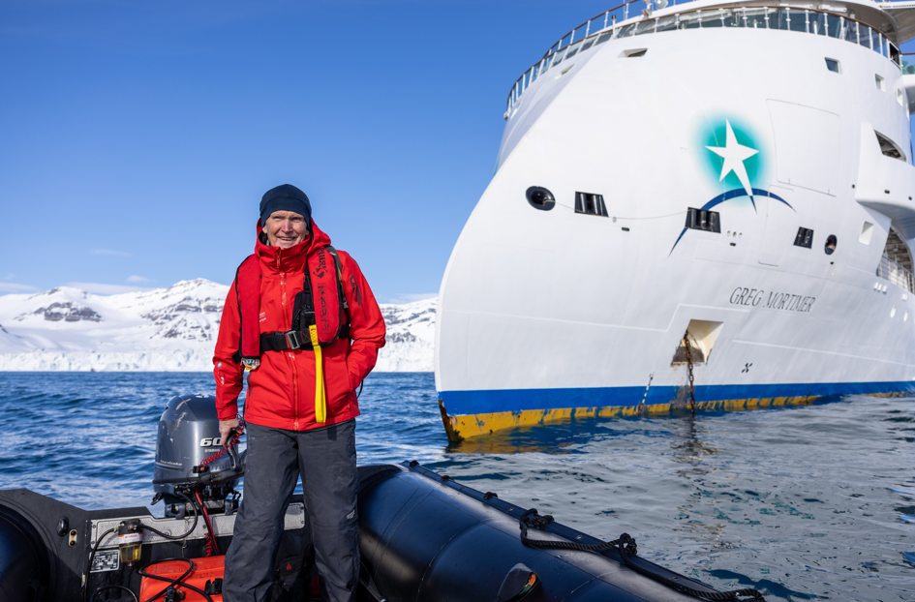

Download Assets HERE
View 35th Anniversary Video HERE

Sydney, Australia - 22 September 2026 - Aurora Expeditions is celebrating 35 years of pioneering expedition travel, marking a journey from a small Australian operation taking adventurous travellers to Antarctica, to a global expedition operator exploring all seven continents.

Founded in Sydney in 1991 by adventurers Greg and Margaret Mortimer, Aurora was built around a simple philosophy: take small groups into extraordinary environments, be flexible enough to respond to nature, and create experiences that inspire a deeper connection with the places being explored. That same year, Aurora became one of the first operators to join the International Association of Antarctica Tour Operators (IAATO), before operating its first Antarctic expedition in 1992.

Over the decades that followed, Aurora helped push the boundaries of expedition travel. Milestones include introducing ice camping and kayaking on the Antarctic Peninsula in 1994, operating the first commercial climbers' expedition to the Peninsula in 1995, launching its first Arctic expedition in 1997, introducing diving in Antarctica in 1998, and in 2001 operating the first passenger expedition to retrace Shackleton's footsteps across South Georgia.

Innovation continued with trips incorporating flights to Antarctica in 2012 and polar snorkelling in 2016. In 2019, Greg Mortimer became the first passenger vessel to feature the Ulstein X-BOW®, followed by Sylvia Earle in 2022 and Douglas Mawson in 2025, completing Aurora's fleet of three purpose-built small expedition ships. In 2024, Aurora became the first — and remains the only — cruise line to achieve Certified B Corporation™ status, before launching Ocean Regeneration in 2025, a circular-impact model focused on decarbonisation and regeneration.

Today, Aurora operates 73 itineraries across seven continents and 26 countries. But as the company reflects on 35 years, its story is as much about the people who shaped it as the milestones themselves.

Margaret Mortimer recalls the earliest voyages for the “joy of sharing it with people” and seeing how expeditioners responded to Antarctica for the first time. Past expeditioners Carole Beale and Ian Evans, who travelled with Aurora in 1994, remember the passion of the Expedition Team and the way it sparked a deeper interest in nature and its protection.

Australian entrepreneur, adventurer and philanthropist Dick Smith AC, a long-time friend of Greg and Margaret who helped launch Aurora Expeditions, has travelled to Antarctica seven times. He recalls landing at Elephant Island aboard Polar Pioneer as “one of the most exciting and moving” experiences of his life, and says Aurora's respect for the environment has remained part of its spirit from the beginning.

For co-owner Michael Alscher, Aurora's next chapter is about growing its reach while protecting what made the company distinctive. “On any given day now, anywhere in the world, there are 500 people on our ships. That’s pretty incredible when you think about it. But what matters most is giving those people an experience that helps them understand why these places are so special – and why they need to be protected.”

As Aurora looks to the future, its ships, technology and destinations will continue to evolve, but the elements at its core remain: small-group exploration, expert-led experiences, a spirit of adventure, respect for the natural world and meaningful connection with the places it visits.

To mark the anniversary, Aurora has brought together founders, past expeditioners, long-time friends and people across the business in a 35th anniversary video reflecting on where Aurora came from, how it has evolved and what it hopes to carry forward into the future.

Watch Aurora Expeditions' 35th anniversary video: https://youtu.be/pf5wNxTbtcE

~ENDS~

About Aurora Expeditions
Aurora Expeditions is an award-winning Australian-owned adventure travel company that has pioneered experiential travel for 35 years. A Certified B Corporation™, a commitment to the protection and preservation of our planet is at the heart of each experience.

Founded on the guiding principles of adventure and endless exploration, our carefully curated small-ship voyages offer immersive activities, more time off ship and thoughtful enrichment programs in some of the planet’s most remote and incredible places.
Aurora’s three purpose-built small ships, Greg Mortimer, Sylvia Earle and Douglas Mawson are designed for global discovery.

