

MEDIA RELEASE

Aurora Expeditions Celebrates 35 Years of Chasing Wonder with Limited-Time Expedition Savings and Air Credit

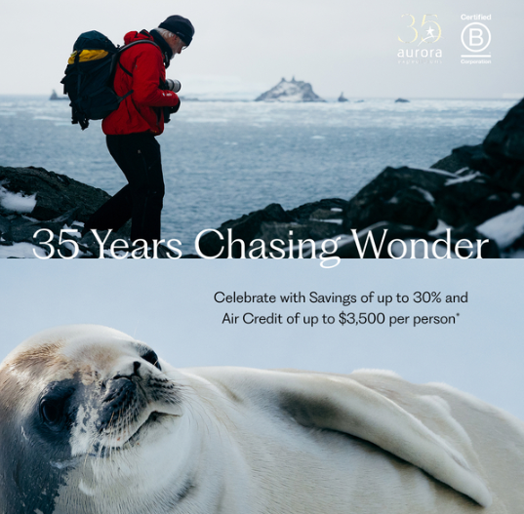

Download Images HERE

New York, US — July 1, 2026 — Aurora Expeditions is marking 35 years of pioneering expedition travel with a limited-time offer giving travelers the opportunity to save up to 30% and receive up to US$3,500 in air credit per person on select Antarctica, Arctic and Global voyages.

Available on select departures booked and deposited between July 1 and September 30, 2026, the offer comes as travelers continue to seek more meaningful, experience-led journeys to remote destinations. From wildlife-rich polar regions to wild coastlines, rainforests, historic islands and bucket-list natural phenomena, the featured voyages highlight the breadth of Aurora Expeditions’ small-ship, expedition-led program.

Featured departures include:

Falklands, South Georgia & Antarctic Peninsula
Departing October 24, 2026, this 22-day voyage combines three of the Southern Ocean’s most celebrated regions, with opportunities to experience the Falkland Islands, the wildlife spectacle of South Georgia and the ice-filled landscapes of the Antarctic Peninsula.
Was US$34,195, now from US$29,066 per person, plus up to US$3,500 air credit per person.

Antarctica Through the Lens
Departing January 25, 2027, this 12-day specialist photography voyage is designed for travelers wanting to capture Antarctica’s wildlife, landscapes and extraordinary light with the support of expert photography guides.
US$24,595 per person, plus up to US$3,000 air credit per person.

Antarctic Peninsula Fly the Drake
Departing January 13, 2027, this 10-day itinerary offers a time-efficient way to experience Antarctica, with a one-way flight across the Drake Passage and a small-ship expedition through the Antarctic Peninsula.
US$25,395 plus up to US$3,500 air credit per person.

Costa Rica & Panama Canal
Departing April 9, 2027, this 12-day warm-water expedition explores tropical coastlines, rainforest ecosystems, wildlife-rich national parks and the iconic Panama Canal.
Was US$16,195, now from US$12,956 per person, plus up to US$3,000 air credit per person.

Wild Scotland
Departing May 31, 2027, this 12-day voyage offers a more immersive way to experience Scotland’s remote islands, rugged coastlines, historic sites and seabird colonies by small ship.
Was US$16,995, now from US$14,446 per person, plus up to US$3,500 air credit per person.

Jewels of the Arctic
Departing August 9, 2027, this 15-day Arctic expedition explores dramatic fjords, glaciers, remote communities and wildlife habitats across one of the world’s most awe-inspiring polar regions.
Was US$24,995, now from US$17,497 per person, plus up to US$3,500 air credit per person.

Northern Lights Explorer - Norway, Greenland, Iceland
Departing August 25, 2027, this 18-day voyage explores the wild landscapes of Greenland and Norway, timed for longer Arctic nights and the region’s famed northern lights.
Was US$21,895, now from US$16,421 per person, plus up to US$3,000 air credit per person.

For more information, visit aurora-expeditions.com or talk to your local travel agent.

~ENDS~

The 35 Years Chasing Wonder offer is valid on new bookings of select departures only, based on availability, and must be booked and deposited between July 1 and September 30, 2026. Savings amount and air credit vary by departure. Air credit is per person and valid for solo, twin and triple share. The offer is combinable only with Aurora Expeditions’ loyalty discounts and back-to-back voyage discounts and is not applicable to group bookings. The offer may be withdrawn at any time and is not redeemable for cash. Full terms and conditions apply.

About Aurora Expeditions
Aurora Expeditions is an award-winning Australian-owned adventure travel company that has pioneered experiential travel for 35 years. A Certified B Corporation™️, a commitment to the protection and preservation of our planet is at the heart of each experience.

Founded on the guiding principles of adventure and endless exploration, our carefully curated small-ship voyages offer immersive activities, more time off ship and thoughtful enrichment programs in some of the planet’s most remote and incredible places.
Aurora’s three purpose-built small ships, Greg Mortimer, Sylvia Earle and Douglas Mawson are designed for global discovery.

